UML DIAGRAM

Game Introduction:

Asteroid Junction is a game designed for solo players, where the objective is to obliterate asteroids using a variety of lasers that will be upgraded after each level. As the player progresses, the gameplay will become more complex and demanding. Along the way, the user will encounter various power-ups like shields, unique lasers, and zoom capabilities. These power-ups can be collected by the player to enhance their abilities and improve their chances of success.

UML Diagram:

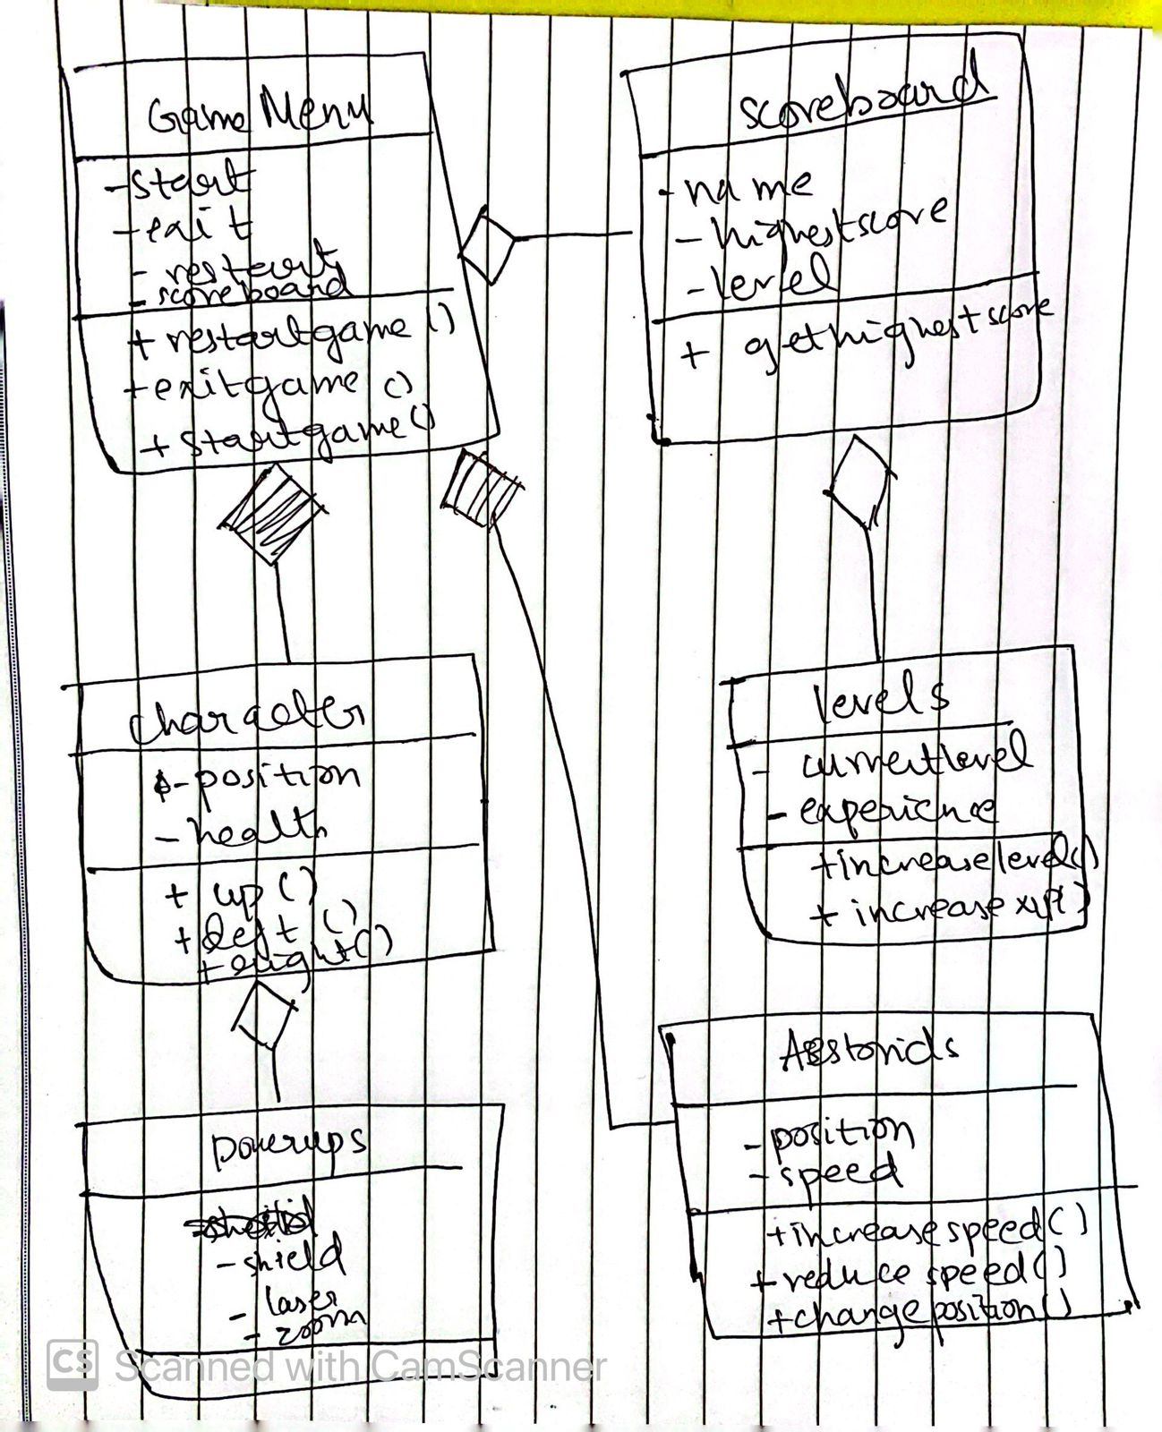

Classes Detail

1. GameMenu:

Will allow users to select start,exit,restart or see scoreboard

1. Scoreboard:

Will collect user’s individual score and collect highest score of each player

1. Character:

Will check user’s movement such as going up,down,left or right.

1. Levels

Saves current level and increases score according to experience points

1. Asteroids

Will detect position of characters and increase speed as levels increase.

1. Powerups

Extra boosts for user to collect.